UNIX Programming OSS5101
Ans 1:

&& Runs the next command if the current command succeeds.
| | Runs the next command if the current command fails.
; Separates commands that should be executed sequentially.
& Runs commands in the background.
- Echo $SHELL chsh

Change directory to /etc , list the content; pwd=/etc ; then list the content of working directory and pwd /// Groups commands to run as a separate process in a subshell. (i.e) list the content of the directory account by creating a subshell and list the content of the current directory.

A pipe is a one-way connection between two related commands. One
command writes its output to the pipe, and the other process reads its input
from the pipe. When two or more commands are connected by the pipe ( | )
operator, they form a pipeline.
A filter is a command that reads its standard input, transforms that input, and
then writes the transformed input to standard output. Filters are typically
used as intermediate commands in pipelines – that is, they are connected by a
pipe ( | ) operator. For example, to cause the ls command to list recursively
the contents of all directories from the current directory to the bottom of the
hierarchy, and then to display the results, enter the following command:
$ ls –R | pg
In this example, the pg command is the filter because it transforms the
output from the ls –R command and displays it one screen at a time.
Certain commands that are not filters have a flag that causes them to act
- Pe –ef >/ /var/process
- /? Human Resource
- This statement tells your system to run the .logout script whenever it Receives a zero (0) signal, which occurs automatically when you log out.
- System login scripts for all users of a particular shell. These scripts create a default environment for all users and are maintained by your system administrator. The Bourne and Korn shells use a system login script called /etc/profile.
.profile.
These scripts allow you to tailor your environment, and you maintain the appropriate file. For example, you could change the default search path or shell prompt. If your default shell is the Bourne or Korn shell, the login script file is called .profile.
- • Hard links allow you to link only files in the same file system. When you create a hard link, you are providing another name for the same file. All the hard link names for a file, including the original name, are on equal footing. It is incorrect to think of one filename as the real name, and another as only a link.
• Soft links or symbolic links allow you to link both files and directories. In addition, you may link both files and directories across different file systems. A symbolic link is actually a distinct file that contains a pointer to another file or directory. This pointer is the pathname to the destination file or directory. Only the original filename is the real name of the file or directory. Unlike a hard link, a soft link is actually only a link.
(J) If the C shell is your default, your environment can be further tailored with the .cshrc file.
(K) It executes when you log in (before .login) and whenever you spawn a subshell. The .cshrc file is the C-shell mechanism that automatically makes variables available to subshells. HOME Specifies the name of your login directory, the directory that becomes the current directory upon completion of a login. The cd command uses the value of HOME as its default value. The login program sets this variable, and it cannot be changed by the individual user.
LOGNAME Specifies your login name. PATH Specifies the directories and the directory order that your system uses to search for, find, and execute commands.
This variable is set by your login scripts.

Whenever you log in, the login program is run. This program actually begins your login session using data stored in the /etc/passwd file, which contains one line of information about each system user.
Working environment is defined by environment variables.

(L)Cat /etc/passwd | grep “ksh” | sort | more.
(M)
- ~c directory_name change the local directory
- ~t from [to] copy a file from the remote host to a file on the local host
- ~< copy a file from the remote host to a file on the local host
- ~p from [to] copy a file from the local host to a file on the remote host
- ~> copy a file from the local host to a file on the remote host
(N)Ls –i
(O)Make a long list in reverse direction , filter rwx permission and send the results to /tmp/a.txt
………………………………………………………………………………………………

Ans 2:

(a) i-nodes
A Unix file is described by an information block called an i-node. There is an i-node on disc for every file on the disc and there is also a copy in kernel memory for every open file. All the information about a file, other than its name, is stored in the i-node. Diagram:
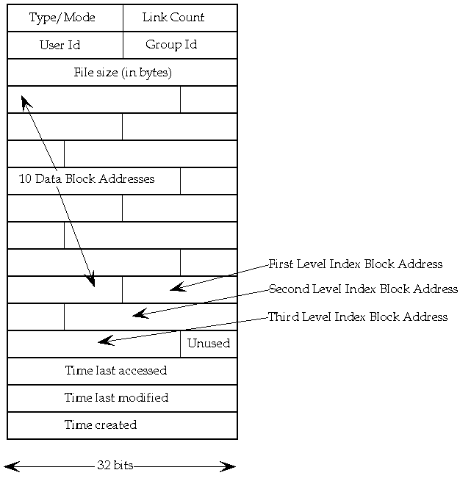

- The five extra information are:
- File access and type information, collectively known as the mode.
- File ownership information.
- Time stamps for last modification, last access and last mode modification.
- Link count.
- File size in bytes.
- Addresses of physical blocks.
- © /bin is but one of many directories that contain applications and utilities. However, /bin typically contains utilities that are essential to system operation. Hence, the shells, file-manipulation commands such as cp and chmod, compression and decompression, and diagnostics reside in /bin.
- The /dev directory is where the user interface to kernel device drivers and other special files are located. The UNIX kernel interface to devices such as modems, printers, disks happens using device drivers built into the kernel. User processes typically access devices (kernel device drivers) via special files. Many of the files are located in the /dev/ directory.

- /etc : There has been controversy over the meaning of the name itself. In early versions of the UNIX Implementation Document from Bell labs, /etc is referred to as the /etcetra directory,^{[9]} as this directory historically held everything that did not belong elsewhere (however, the FHS restricts /etc to static configuration files and may not contain binaries).^{[10]} Since the publication of early documentation, the directory name has been re-designated in various ways.
- /lib is the coffer for essential system libraries. In modern UNIX, system libraries are typically shared, meaning that the libraries are not linked and included in each binary (which would waste space, at the least), but are loaded on demand when needed and shared by many applications at once. Hence, core applications and utilities installed with UNIX require the libraries in /lib to run, and you need at least a small handful of the libraries to create new executables from source code. All files here are vital, and the corruption or removal (whether intentional or accidental) of even one file can render a system useless.
- lost+found is in general part of the Unix Filesystem of Mac OS (and other Unix and Linux systems too) It is normally found on each partition/drive on your system, as long as it is not formatted in Windows/DOS formats.
- /usr is the umbrella for a great number of files. End-user applications—from editors, games, and interfaces, to system features—are here, as is the library of man pages along with much more. Chances are that if the file is useful but not mandatory for system operation, you'll find it in /usr.
- /tmp, or "temporary," is the system-wide scratch pad. Your Web server might stash session data files here, and other utilities use the space in /tmp for caching intermediate results. Files in /tmp are considered disposable.

(d) The cu command connect to a remote host that has a long-distance telephone number of 2348472. The -s option specifies a transmission rate of 600 baud.
(e) The three daemons that should be running are:
- Nfsd : The NFS daemon which services requests from the NFS clients.
- Mountd: The NFS mount daemon which carries out the requests that nfsd passes on to it.
- Rpcbind: This daemon allows NFS clients to discover which port the NFS server is using
(f)result || rm result.tmp.
(g) # uux "UTM!cat UTM!/user/doc/experiment UOM!/usr1/doc/final experiment > UTM!/user/doc/project"
The uux command uses the operating system cat command to concatenate the /user/doc/experiment file located on host UTM, with the /usr1/doc/final experiment file located on host UOM. The result is placed in the /user/doc/project file on host UTM.
(h) UTM% uucp /usr/staff/IT UOM\!~uucp
Copy the /usr/staff/IT file from local host UTM to the ~uucp public directory on remote host UOM, making use of the C Shell

Ans:3
(a)
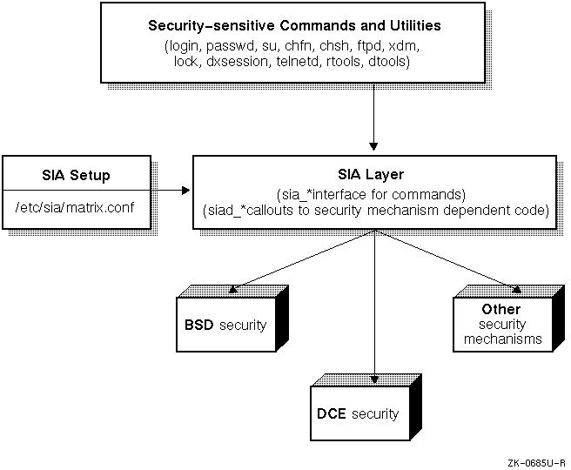
(b) The authentication subsystem verifies that users who log in to the system have the required password. It is the framework in which processes, protected subsystems, and the kernel work together to ensure that only authorized users and their processes gain access to the system.
The authentication subsystem uses and maintains the following security databases. These databases contain parameters and statistics for the system, for users, and for terminals.
- Protected Password database (prpasswd)
- System Defaults database (default)
- Terminal Control database (ttys)
- File Control database (files)
- Device Assignment database (devassign)
(c) # nm -Bn /vmunix | grep sp_insert_ir
(d) # dbx /vmunix -k
(e)
- Install the layered security product as described in the product's installation procedure.
- Change directory to /etc/sia.
- Link the /etc/sia/matrix.conf file to the new matrix.conf file provided by the layered product using the ln -sf new_matrix.conf matrix.conf command.
- Reboot your system.

Ans 4:
  - [ 1 mark for each , total 10 marks ]
/etc/passwd This file contains individual user information for all users
of the system.
/etc/group This file contains group information for all groups on the
system.
/etc/hosts. Ip address assign to the name of a machine.
/etc/resolve.conf. Your local host is listed in the /etc/hosts.equiv file on the remote
host.
/etc/routes …Gateway ip address.
/sbin/sh also contains utilities crucial to system operation and maintenance. However, the programs found in /sbin can be executed only by superusers—hence, "superuser-bin" or /sbin in a bourne shell
/etc/hosts.equiv
In the following situations, rlogin will not prompt for a password:
If your local host is listed in the /etc/hosts.equiv file on the remote host.
.$HOME/ .rhosts. The most common use of the $HOME/.rhosts file is to simplify remote logins between multiple accounts owned by the same user. If you have active accounts on more than one system, you may need to copy files from one account to the other or remotely log in to one account from the other. The \.rhosts file is ideally suited to this type of use.

Rcp –p UTM:/u/cave/assign/project UOM:/u/hut/project1

© Remote Procedure Call (RPC) is a protocol that one program can use to request a service from a program located in another computer in a network without having to understand network details. (A procedure call is also sometimes known as a function call or a subroutine call.) RPC uses the client/server model. The requesting program is a client and the service-providing program is the server. Like a regular or local procedure call, an RPC is a synchronous operation requiring the requesting program to be suspended until the results of the remote procedure are returned. However, the use of lightweight processes or threads that share the same address space allows multiple RPCs to be performed concurrently.
When program statements that use RPC are compiled into an executable program, a stub is included in the compiled code that acts as the representative of the remote procedure code. When the program is run and the procedure call is issued, the stub receives the request and forwards it to a client runtime program in the local computer. The client runtime program has the knowledge of how to address the remote computer and server application and sends the message across the network that requests the remote procedure. Similarly, the server includes a runtime program and stub that interface with the remote procedure itself. Results are returned the same way

Ans 5:
- The Logical Storage Manager (LSM) is an integrated, host-based disk storage management tool that protects against data loss, improves disk input/output (I/O) performance, and customizes the disk configuration. System administrators use LSM to perform disk management functions without disrupting users or applications accessing data on those disks.
- Volume Device Driver:
The LSM (volume device driver ) is an installable driver that maps the logical configuration of the system to the physical disk configuration. Although the volume device driver resides between the disk device and the applications, it maps the configuration transparently to the file systems, databases, and applications above it. Thus, applications do not need to be changed in order to access data on LSM volumes. The volume device driver implements striping or concatenation, read and write error handing, and mirroring in LSM configurations.
© Manages disk administration: Frees you from the task of partitioning disks and maintaining disk-space administration. However, LSM allows you to keep control over disk partitioning and space allocation, if desired.
Allows transparent disk configuration changes: Allows you to change the disk configuration without rebooting or otherwise interrupting users. Also allows routine administrative tasks, such as file system backup, while the system is in active use.
Stores large file systems: Enables multiple physical disks to be combined to form a single, larger logical volume.
Eases system management: Simplifies the management of disk configurations by providing convenient interfaces and utilities to add, move, replace, and remove disks.
Protects against data loss: Protects against data loss due to hardware malfunction by creating a mirror (duplicate) image of important file systems and databases.
Increases disk performance: Improves disk I/O performance through the use of striping, which is the interleaving of data within the volume across several physical disks.
Provides recovery from boot disk failure: Allows you to mirror the root file system and swap partition. By duplicating the disks that are critical to booting, LSM ensures that no single disk failure will leave your system unusable.
(d) The partitions on a physical device are mapped by a partition table called the disklabel. The disk's partitions and disk label have the following characteristics:
- The disk label maps a physical disk to a maximum of eight partitions that are labeled from a to h.
- Partition c covers the whole disk.
- The partitions can overlap each other.
- Each partition has an fstype attribute. If a partition is not in use, the fstype is unused. If a partition is in use, the fstype can have values such as 4.2BSD, AdvFS, swap, LSMsimp, LSMpubl, LSMpriv, or LSMnopriv.
- The disk label resides at block 0 of a physical device. For most devices, the default disk label is defined in /etc/disktab.
- You can modify an online disk label using the utility program /usr/sbin/disklabel.
(e) ) Need then after elif:
#!/bin/sh
users=`who | wc -l`
if [ $users -ge 4 ]
then
echo "Heavy load!"
elif [ $users -gt 1 ]
then
echo "Medium load"
else
echo 'Just me!'
fi

(F) The example that follows is for disk rz19, which has hardware problems and needs to be replaced. Disk rz19 has been added to the rootdg disk group as disk02. Follow these steps:
- Remove the LSM disk, disk02, from the rootdg disk group. To do this, use the -k flag with the voldg command to keep the disk media records associated with disk02. The subdisk records associated with disk02 will continue to point to the disk media record. For example:
# voldg -g rootdg -k rmdisk disk02
- If you have a spare disk available that is at least as large as the rz19 disk (for example, rz20), you can use the spare disk to replace the failed disk. Initialize the new rz20 disk using similar parameters to those used for rz19. For example:
# voldisksetup -i rz20 privlen=1024 nconfig=1 nlogs=1
- Add the new rz20 disk to the rootdg disk group. Use the -k flag to associate a new disk with the existing disk media records in the disk group.
# voldg -g rootdg -k adddisk disk02=rz20
- If the failed disk rz19 has any volumes with only one plex, you must restore data to the volumes from backup media. If the volumes using rz19 are mirrored, resynchronize the volumes by issuing the following command:
# volrecover -sb disk02

